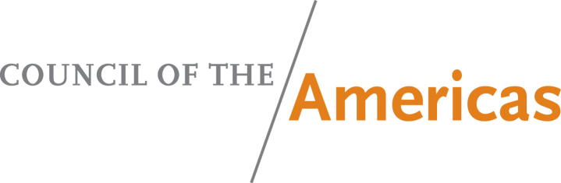
PRESS REGISTRATION

43nd Washington Conference on the Americas
Wednesday, May 8, 2013

U.S. Department of State
Press Access from the 23rd Street Entrance
(between C and D streets)
Morning Session: 8:45 a.m. – 12:30 p.m. to be held in the Loy Henderson Conference Room
Pre-set time for press TV equipment is 5:30 a.m. from the 23rd Street entrance.
First access time for journalists and still photographers is 8:00 a.m. from the 23rd Street entrance.
Final access time for all press is 10:30 a.m. from the 23rd Street entrance.
Luncheon: 1:00 p.m. – 2:30 p.m. to be held in the Ben Franklin Diplomatic Reception Hall (8th floor)
Pool access from 23rd Street at 12:30 p.m. and from the Loy Henderson Conference Room at 1:20 p.m.

Please complete the form below and email it to Adriana La Rotta: alarotta@as-coa.org
Press Registration Deadline is May 6, 2013
Any questions, please call (212) 277-8384

FIRST NAME:

LAST NAME:

D.O.B (DD/MM/YY):

ID NUMBER:

STATE/COUNTRY OF ISSUANCE:

TYPE OF DOCUMENT:

COMPANY:

TITLE:
DIVISION:

STREET ADDRESS:

CITY:

STATE:

ZIP:

PHONE:

FAX:

E-MAIL:

Credentials:
Admittance to the Department of State for this event will require PRESS CREDENTIALS with Photo Identification. Media representatives may attend this event upon presentation of one of the following: (1) a U.S. Government-issued identification card (Department of State, White House, Congress, Department of Defense or Foreign Press Center); (2) a media-issued photo identification card; or (3) a letter from their employer on letterhead verifying their employment as a journalist, accompanied by an official photo identification card (driver's license, passport). Press should allow adequate time (at least 15 minutes) to process through security. Please note that conducting interviews in the hallways of the State Department is prohibited.

